BEARINGS
Pearson Edexcel - Tuesday 11 June 2019 - Paper 3 (Calculator) Higher Tier
1.
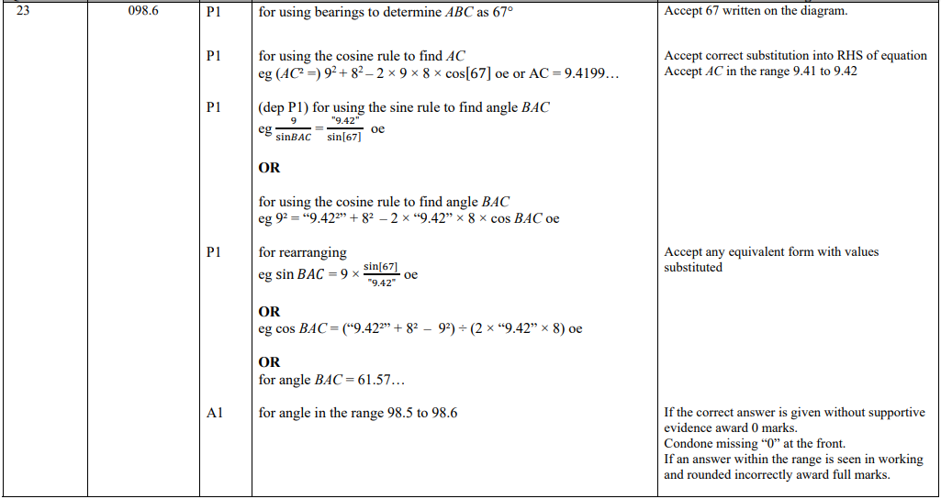
Pearson Edexcel - Specimen Papers Set 1 - Paper 2 (Calculator) Higher Tier
2.
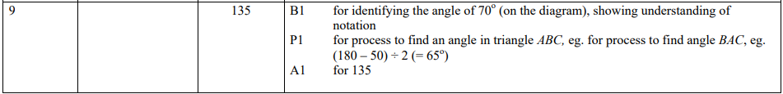
Pearson Edexcel - Wednesday 4 November 2015 - Paper 1 (Non-Calculator) Higher Tier
3.
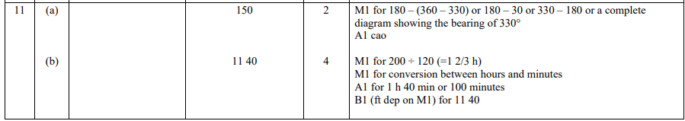
Pearson Edexcel - Monday 8 June 2015 - Paper 2 (Calculator) Higher Tier
4.
Pearson Edexcel - Friday 13 June 2014 - Paper 2 (Calculator) Higher Tier
5.
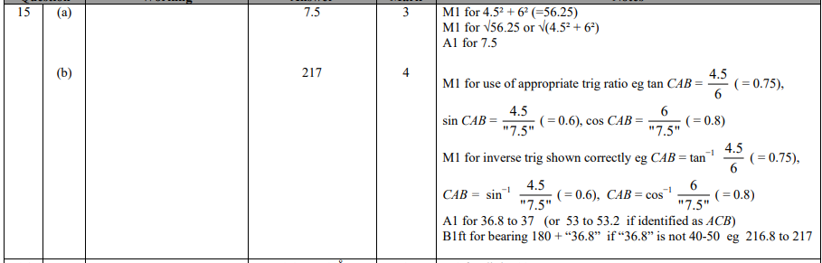
Pearson Edexcel - Tuesday 6 November 2012 - Paper 1 (Non-Calculator) Higher Tier
6.
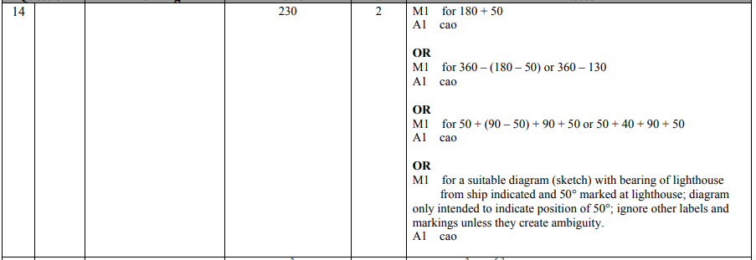
Pearson Edexcel - Monday 11 June 2012 - Paper 1 (Non-Calculator) Higher Tier
7.
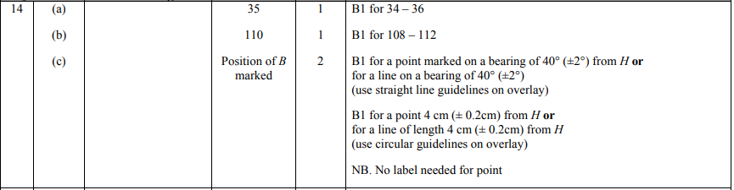
Pearson Edexcel - Thursday 5 November 2009 - Paper 3 (Non-Calculator) Higher Tier
8.
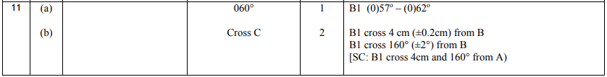 OCR GSCE – Tuesday 11 June 2019 – Paper 6 (Calculator) Higher Tier
9.
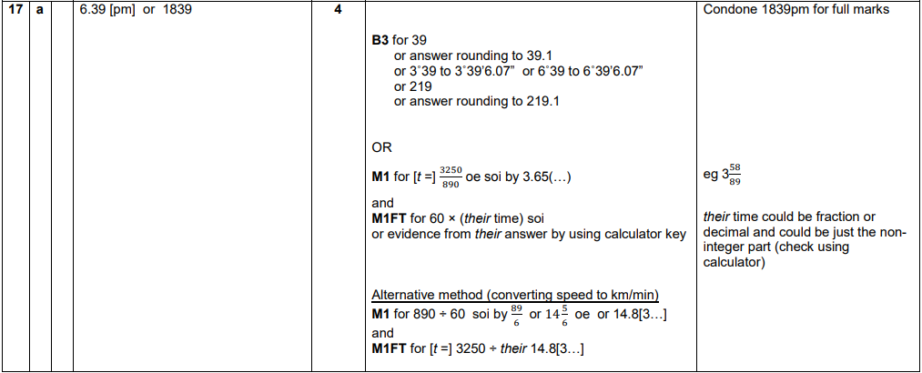
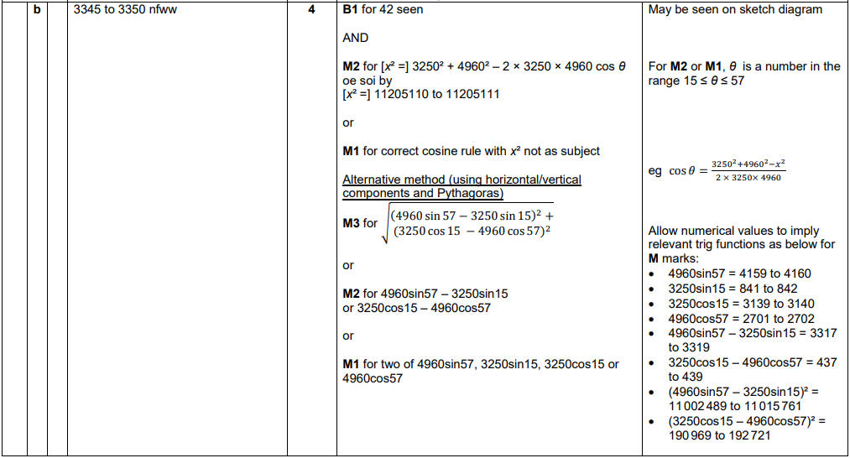

OCR GSCE – Wednesday 8 November 2017 – Paper 6 (Calculator) Higher Tier
10.
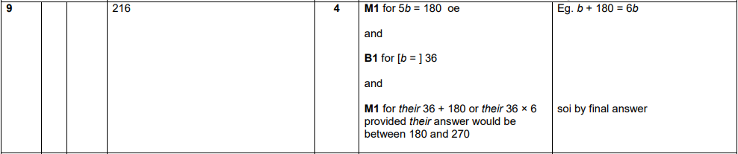
OCR GSCE – Thursday 25 May 2017 – Paper 4 (Calculator) Higher Tier
11.
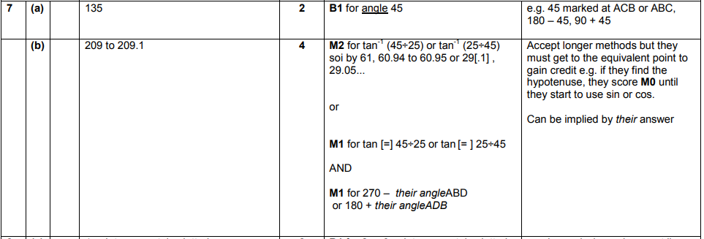
AQA GSCE – Thursday 8 November 2018 – Paper 2 (Calculator) Higher Tier
12.
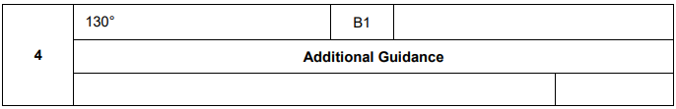
AQA GSCE – Tuesday 13 June 2017 – Paper 3 (Calculator) Higher Tier
13.
